5/11/2018 Notes:

Today, we had a meeting to discuss future plans and how we will make things come to be.

Materials we still need:

* Male to male jumper wires
* ESP8266 12E WiFi Shield – to connect our Arduino to WiFi
* Trash bin (with lid)

Things researched:

* How to connect the ESP8266 12E WiFi Shield to the Arduino…

<http://www.instructables.com/id/ESP-12E-ESP8266-With-Arduino-Uno-Getting-Connected/>

* How to connect and use the Servo motor for our trash bin.

<https://www.hackster.io/omer-beden/smart-trash-77be58>

<http://omer.beden.net/akilli-cop-kutusu/>

https://www.arduino.cc/en/Reference/Servo

* Using blynk, updating the values in the application and virtual pins.

<http://docs.blynk.cc/#blynk-main-operations-virtual-pins>

Until we have everything connected, we can only work on the software side of the project. Even so, we cannot test our software until a future meeting once we have our supplies.

What we need to do:

EVERYTHING.

Figure out an incentive system.

5/17/2018 Notes:

Work-a-thon

We got male-to-male jumper wires from supply.

* Red wire – gnd connective
* Pink wire – 3.3v -> VCC
* Green wire – digital 7 -> sig

I uploaded some sample code onto the Arduino IDE and got it running, so now it can take the input from the ultrasonic ranger.

I am also trying to connect the ESP 12E to the breadboard and everything, but I am still at a loss. Dillon recommended that I look up voltage divider, so I will do that soon.

5/21/2018 Notes:

We are going to try to connect the ESP8266 to the breadboard, but we do not know the pinout because it was a spare instead of what we initially ordered.

PINOUT:

<https://components101.com/wireless/esp8266-pinout-configuration-features-datasheet>

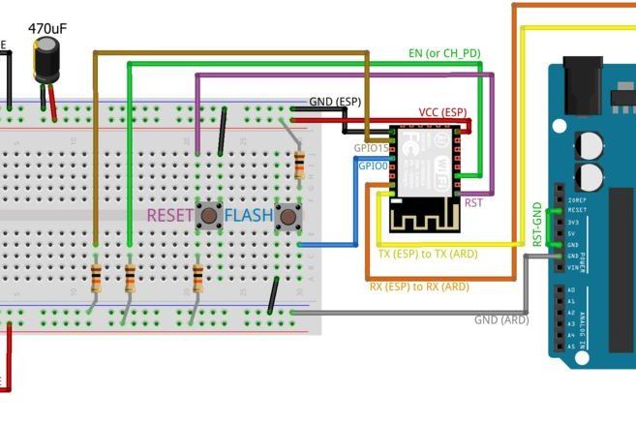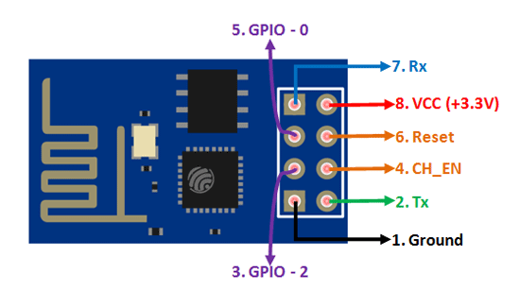

Ground – short wire

GP100 – short wire

VCC – short wire

Rx – long wire

EN – long wire

GPO15 – long wire

RST – long wire

Tx – long wire

Soldering is rough.

Agenda:

We need to find a way to take a user input from Blynk. This will be for the height of the trash can, from which we will calculate the %fullness.

We also need to continue soldering and connect the Arduino UNO to WiFi.